**CSE 115L – Programming Language I Lab**

**Lab 14 - Pointers**

In this lab, we will learn how to use pointers. A pointer is a variable that stores the address of another variable. By storing the address of a variable, a pointer points to that variable. The pointer variable can be of any data type, such as int , float, char or double, depending on the type of the variable it stores the address of.

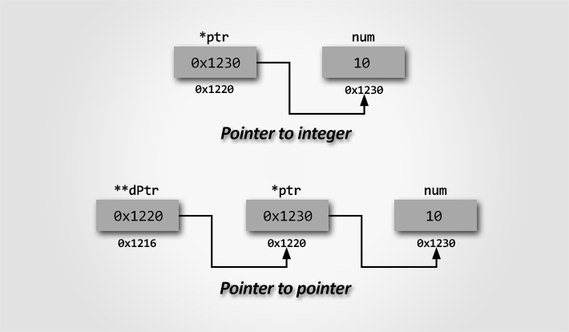

Key points to remember:

• Pointer variables store the memory addresses of other variables.

• An address is always an integer number. • Always initialize pointer with NULL, i.e. int *p = NULL. NULL means 0.

• If NULL is assigned to a pointer, it means it does not points to anything.

• The & symbol is used to get the address of variables.

• The * symbol is used to get the value at the address a pointer points to.

• Integer arithmetic operations can be performed on pointer variables.

|  |  |
| --- | --- |
| Here is how we can declare pointers:  int *p; | You can also declare pointers in these ways:  int c;  printf("%d", &c); //&c Points Location |
| Assigning addresses to Pointers:  int c, *pc;  c = 5;  pc = &c; | Get Value of the Thing Pointed by Pointers:  int c, *pc;  c = 5;  pc = &c;  printf("%d", *pc); //Output: 5 |

Changing Value Pointed by Pointers

|  |  |
| --- | --- |
| int c, *pc;  c = 5;  pc = &c;  *pc = 1;  printf("%d", *pc); // Ouptut: 1  printf("%d", c); // Output: 1 | int c, *pc, d;  c = 5;  d = -15;  pc = &c;  printf("%d", *pc); //Output: 5  pc = &d;  printf("%d", *pc); //Ouptut: -15 |

Working of Pointers

|  |
| --- |
| #include <stdio.h>  int main()  {  int c, *pc;    c = 22;  printf("Address of c: %p\n", &c);  printf("Value of c: %d\n\n", c); // What is the output?    pc = &c;  printf("Address of pointer pc: %p\n", pc);  printf("Content of pointer pc: %d\n\n", *pc); // What is the output?    c = 11;  printf("Address of pointer pc: %p\n", pc);  printf("Content of pointer pc: %d\n\n", *pc); // What is the output?    *pc = 2;  printf("Address of c: %p\n", &c);  printf("Value of c: %d\n\n", c); // What is the output?  return 0;  } |

Common mistakes when working with Pointers

|  |
| --- |
| int c, *pc;  // pc is address but c is not  pc = c; // Error  // &c is address but *pc is not  *pc = &c; // Error  // both &c and pc are addresses  pc = &c;  // both c and *pc values  *pc = c; |

Returning Pointers (Using Function)

|  |
| --- |
| #include<stdio.h>  int *findMid(int a[], int n);  int main()  {  int a[] = {1,2,3,4,5};  int n = sizeof(a) / sizeof(a[0]);  int *mid = findMid(a,n);  printf("%d", *mid);  return 0;  }  int *findMid(int a[], int n)  {  return &a[n/2];  } |